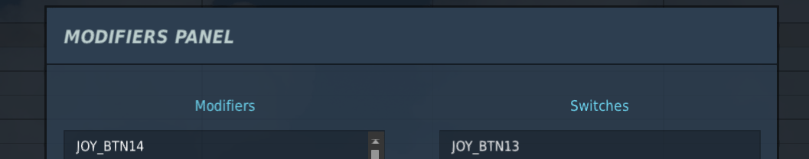
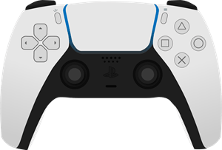
IAT OFS / WAS Gun
Store / WAS Missile
Slave / WAS A/A
IAT Center / WAS Rocket / Display Zoom
SRS PTT (in SRS)

SRS Intercom (in SRS)
TADS FLIR
TADS TV
RHG Enter / Lase Track OFF / FCR Cont. Scan
LHG Courser Controller X+Y (Axis)
Weapon Trigger Second
FLIR Polarity
LMC / Lase Track Manual / FCR Single Scan
RHG MAN TRK Controller X+Y (Axis)
TADS FOV N / HMD / FCR Scan Z

TADS FOV N / FCR / FCR Scan N

TADS FOV M / LINK / FCR Scan M

TADS FOV W / HMD / FCR Scan W
LRFD Second
PS Taste (PS) = Switch 1
Touchpad (TP)= Modifikator 1

